**Phonovation**

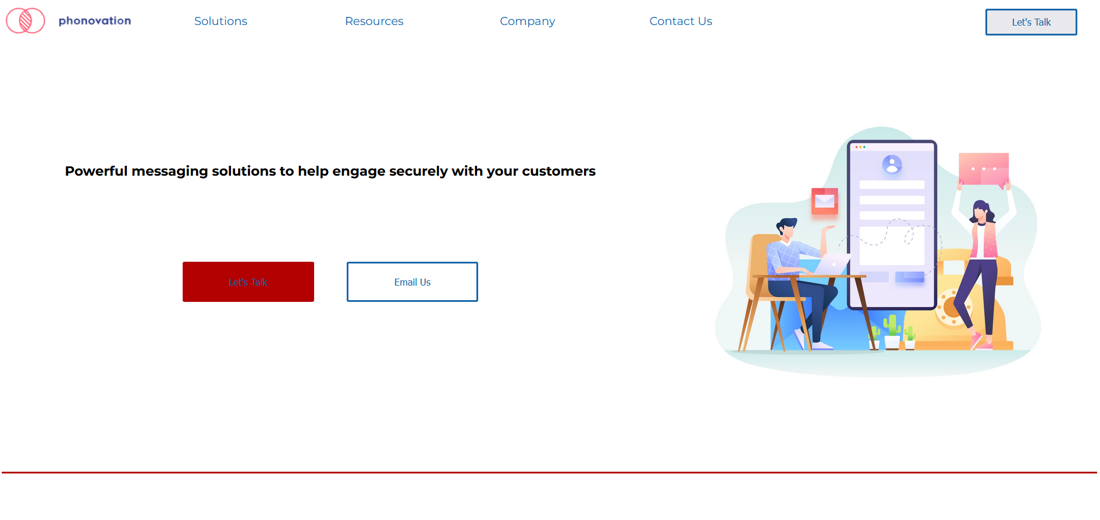

Miguel Angel Vinas

**Submitted to:** Lisa Murphy

Tuesday 13th of December 2022

Table of Contents

1. Executive Summary 1

2. Project Work 1

3. Design Process 1

4. Testing & Responsiveness 1

5. Conclusion 1

6. References 2

To update table of contents, right click, update field, then update entire table.

# Executive Summary

When I started working in my current company, Phonovation, I did an analysis research on the company and a competitive research within our market in order to know how other companies in our business spectrum were doing in terms of marketing and website creation.

What I found out was that our competitors had a better online presence, more stylized websites, more dynamic content and clearer ways to interact with them than us.

User research and testing made me realize that our website (www.phonovation.com) was outdated and did not provide a great user experience nor showed the heart of what we truly are, an innovative and disruptive company in our field.

Because of that I intended to design and create a new website that emphasized in the user, that was easy to use and with a clear layout.

Pop in links here to your website – Git page etc

# Project Work

I did the project on my own due to time constrains.

My first step was to understand the architectural design of the website. (Document attached in the folder and screenshot below)

The architectural design of the website was simple but with several pain points for the user.

Once I understood what I wanted to do with the new design, my second step was to create wireframes in order to know how I wanted to lay out said design in the actual website.

I knew that responsiveness was not an issue as the website is mainly used and seen through desktop devices, however I wanted to create a responsive website.

I started doing some research on different frameworks (Bulma, Skeleton and Flexbox) and started creating the website with those frameworks. I was not convinced by any of them and each time that I was not convinced it meant to discard the work.

In the end I discovered CSSGRID and thought that it was the perfect framework for what I wanted to create as it allowed me to place each item wherever I wanted it to be and kept the HTML clean and easy to read.

# Design Process

Colour palette, fonts used, buttons used etc. Lots of images and reasons why certain things were done.

# Testing & Responsiveness

Wireframes for Phonovation's website attached.

Homepage

Products

Company

Contact Us

The form was quite interesting to create. I did not know how to make the form to validate a submission so I looked on the internet the things that were needed.

Turns out I needed to have some sort of back-end and where to store the responses and that back-end was provided by several vendors.

I chose one that was free, easy to setup and with great instructions and two lines of code.

# Conclusion

I think that the main take for me is to choose one framework and stick with it regardless of what my designs on the wireframes look like. Had I chosen to stick with Bulma, I would have had the site coded and written in 2 days and I would have been able to optimise the website, create the SEO, etc.

Because I didn't like how it looked because of Bulma I lost two weeks trying to gather information about other frameworks and trying to learn how to use them with not very successful results.

I also discovered very late that the site only worked as expected and displayed as expected on Firefox, which is something that I need to investigate further.

As this is an ongoing project for me I am going to continue working on it and I will eventually deploy it in our internal servers for it to go live in the middle of 2023 if the business approves.

# References

Google. (2022, December Thrusday). *Google Pages*. Retrieved from Google: www.google.ie